Table of contents

1. Introduction

This document, which is a part of MT project, provides a high level overview and explains the whole architecture of the project; and this introduction section presents an over view of the document

1. Purpose

This document provides a comprehensive architectural overview of the system, using a number of different architectural views to depict different aspects of the system. It is intended to capture and convey the significant architectural decisions that have been made on the system. This document is intended for both of supervisor and developers of Olives project, submitted to instructor and stored in the team’s capstone project deliverables kit.

1. Scope

This document applies to the overall design of the system. It contains information relating to the architectural design of the software, the structure of the system and the constraints. This explains main parts of system that is architecture of application

1. Definitions, acronyms and abbreviations

|  |  |  |
| --- | --- | --- |
| Abbreviation | Description | Note |
| Olives |  | Project name |
| SAD | Software Architecture Design |  |

1. References

|  |  |  |
| --- | --- | --- |
| No | Document name | Source |
| 1 | Software Requirements Specification | Internal Resource |
| 2 | Screen Design | Internal Resource |

1. Architectural representation
   1. Overall System Architectural

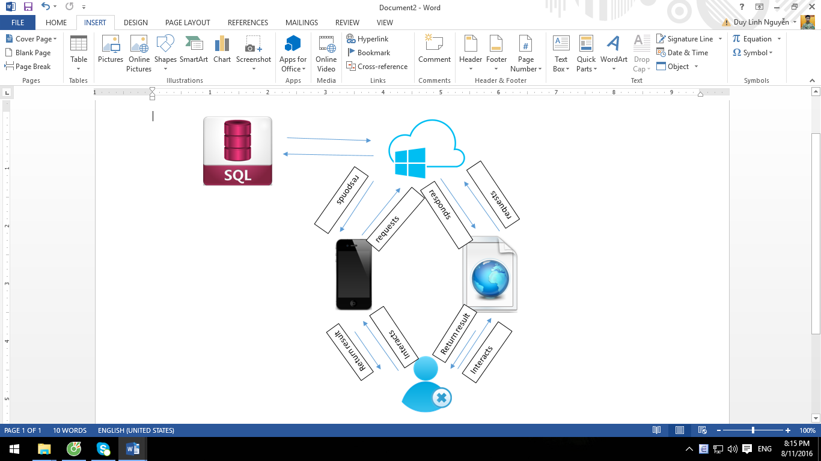

The Olives system :

* Includes 2 applications built on Objective-C language:
  + Olives for patients.
  + Olives for doctors.
* Includes 1 website built on Angular.
* Applications send requests to server and receive responses and render the data to screen to help user interact with. For notifications, messages, applications create persistent connections to the server and transfer realtime data.
* Api layer is hosted on Azure cloud hosting, which connects to a SQL database for data management, processes data and responds to clients.

* 1. Application Architecture